Chapter 17, Problem 35.

If v_{s} in the circuit of Fig. 17.71 is the same as function f₂(t) in Fig. 17.56(b), determine the dc component and the first three nonzero harmonics of v_{o}(t).

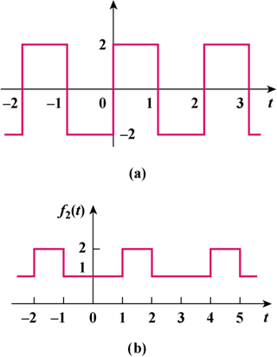
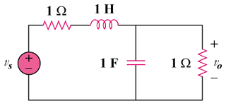

Figure 17.71
For Prob. 17.35

Figure 17.56(b)
For Prob. 17.35.

